**VISUALFORCE PAGE IN SALESFORCE**

**AIM:**

To create a Visualforce web page in Salesforce Lightning Experience.

**PROCEDURE:**

**About Visualforce Page:**

* Visualforce pages are basic building blocks for application developers. A Visualforce page is similar to a standard Web page, but includes powerful features to access, display, and update your organization’s data.
* Pages can be referenced and invoked via a unique URL, just as they would be on a traditional web server.
* Visualforce uses a tag-based markup language that’s similar to HTML.

**STEP 1 :** Login to Salesforce developer account.

**STEP 2 :** Go to Setup à Quick Find à Type “Visualforce Pages”.

A new, blank Visualforce page opens in a new window/tab.

Then, fill the following fields:

Label: My Acc Page

Name: My Acc Page

Description: My User Interface to insert new records in Account object.

**STEP 3 :** In the editor, enter the apex script code to create Visualforce UI (ie.,

front end).

Insert records for Account – Standard object.

**STEP 4 :**Then, Click “Preview” button to open the Visualforce webpage in the

browser and insert the following fields: Account name, Phone number,

Website and Description.

**CODING:**

(Apex Code to Create a Visualforce Page)

<apex:pagestandardController="Account">

<apex:sectionHeader title="Account" subtitle="New Account"/>

<apex:form>

<apex:pageBlock Title="Account" mode="edit">

<apex:pageBlockButtons>

<apex:commandButton value="Save" action="{!Save}"/>

<apex:commandButton value="Cancel" action="{!Cancel}"/>

</apex:pageBlockButtons>

<apex:pageBlockSection title="Account Information" columns="2">

<apex:inputField value="{!Account.Name}"/>

<apex:inputField value="{!Account.Phone}"/>

<apex:inputField value="{!Account.Website}"/>

</apex:pageBlockSection>

<apex:pageBlockSection columns="1">

<apex:inputTextArea value="{!Account.Description}" cols="60" rows="5" tabIndex="50"/>

</apex:pageBlockSection>

</apex:pageBlock>

</apex:form>

</apex:page>

**OUTPUT:**

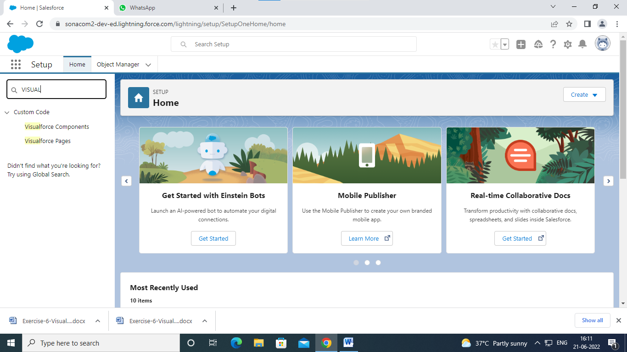

GOTO VISUAL FORCE PAGE

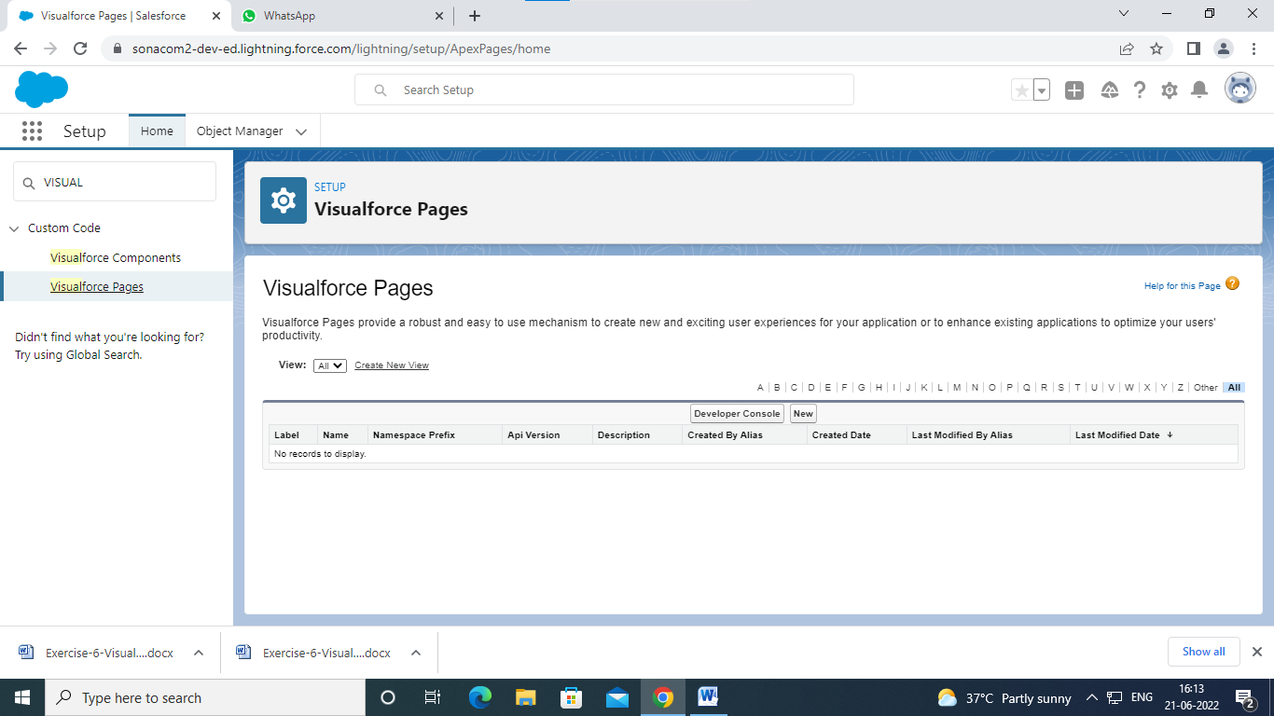

CLICK NEW

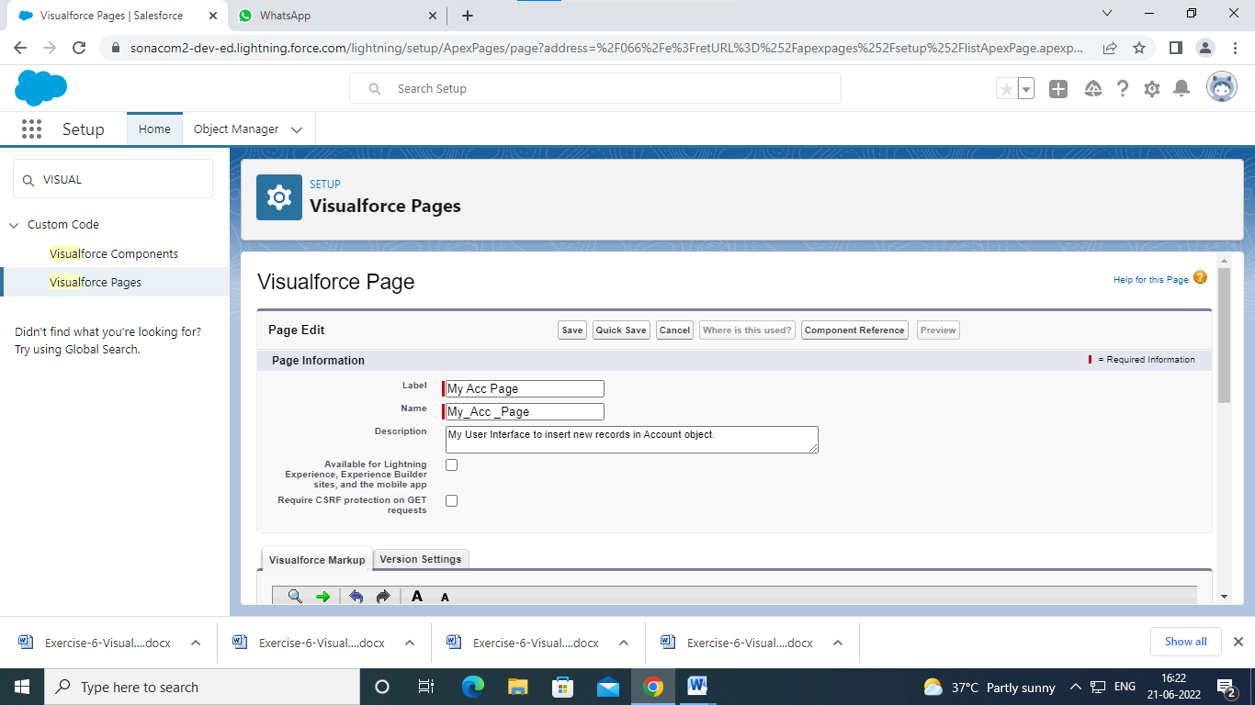

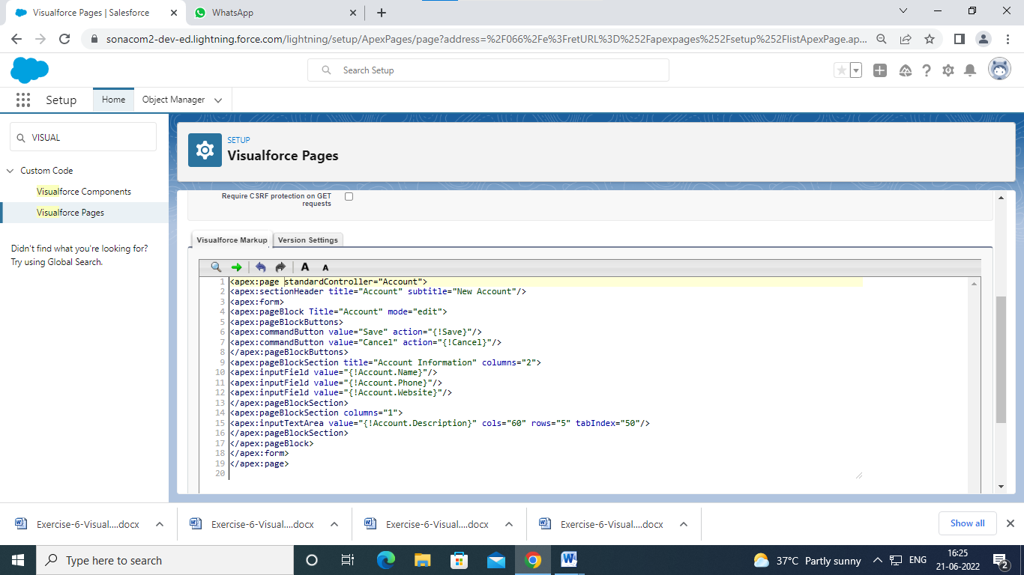

Click save

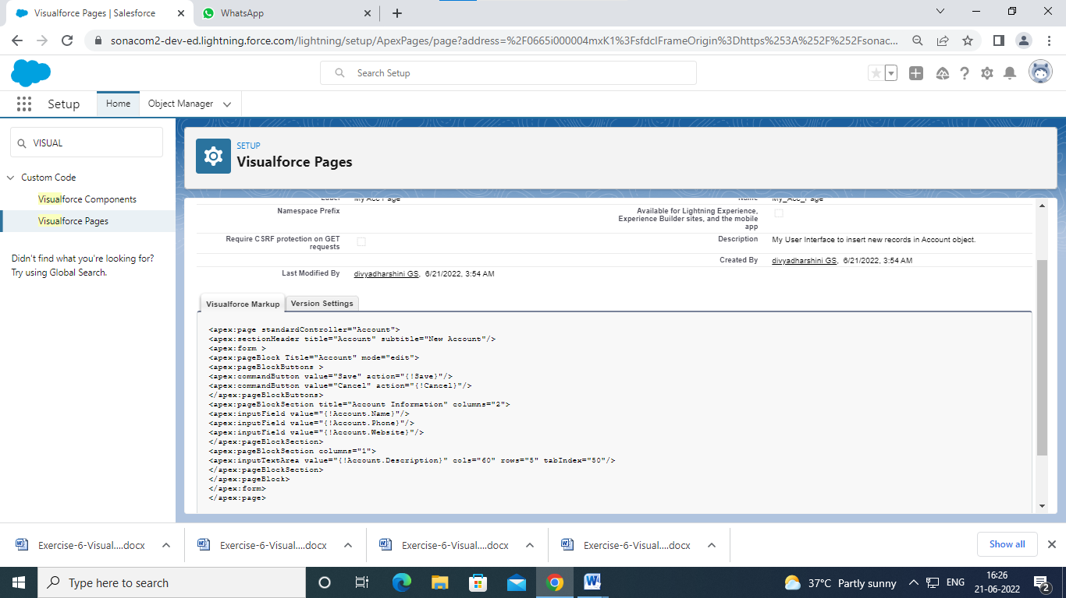

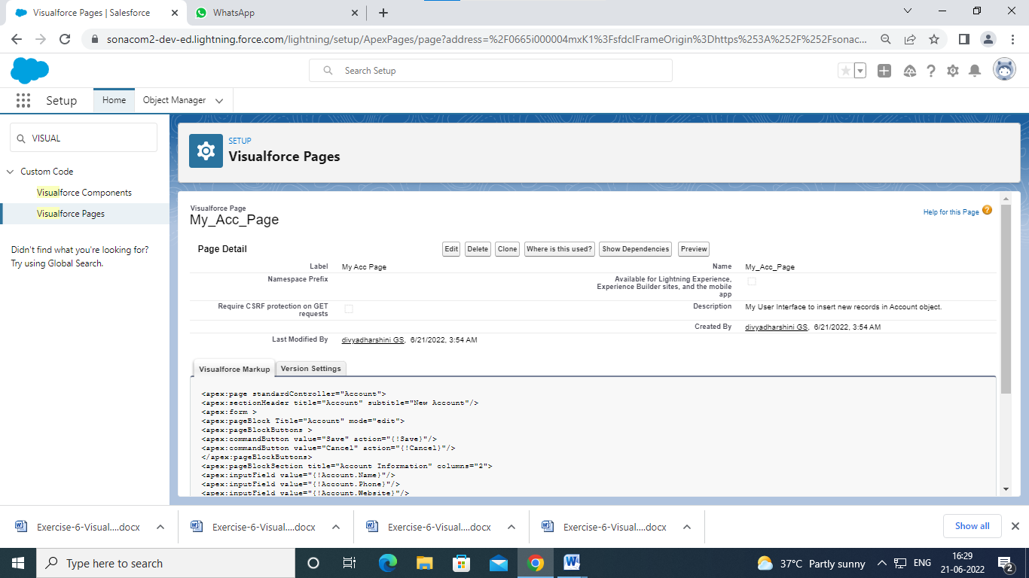

Click preview

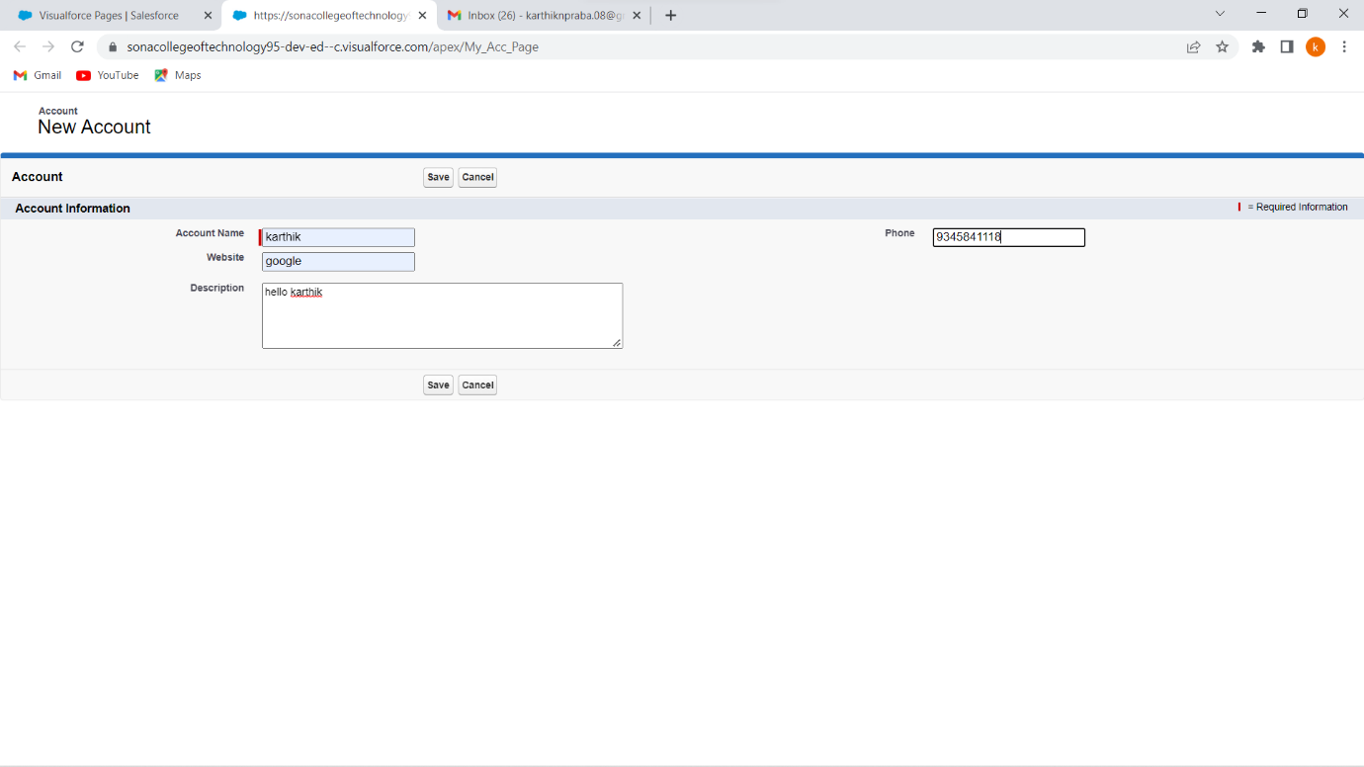

Click save

Go to details

